ENPH 353 – 2022

Pendulum Experiment Worksheet

Student Name: Keegan Kelly

Lab Partner(s) Name(s): Gabe Wilson, River Trantertiffin

Since we are beginning this experiment before a discussion of lab notebooks and reports, please use this Word file to answer questions. Later exercises will involve a full laboratory report. Please work on this worksheet TOGETHER in class, but SEPARATELY once you have left class. Each student must upload their own worksheet.

1. Sketch the apparatus and measure the physical dimensions of it (lengths, diameters,

masses). Using the electronic balance and calipers, measure the quantities (and uncertainties

on these quantities) that you will need to find the centre of mass and moment of inertia of the

pendulum (aluminum rod and steel plate). Since we will be measuring the frequency quite

accurately, it is important that you do the best you can in measuring the physical parameters

of the pendulum. Be reasonable about the uncertainties - often “half of the last decimal place”

isn’t a good description of the uncertainty if noise or systematic problems dominate. This can

be done on paper and a photo imported to your electronic lab notebook - or done directly in

the notebook if technology allows.

1. The simplest model is the simple frictionless pendulum: assume the rod is much less

massive than the steel disk at the bottom and that this plate is pointlike and predict what the

period of the oscillation will be using equation 8.

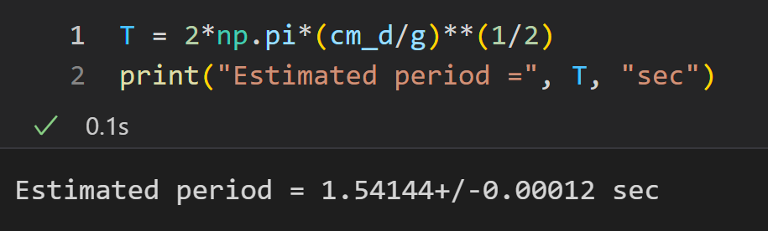

1. Time a single oscillation of the pendulum for a small angle. What is your estimate of

the uncertainty of this measurement? Repeat the measurement 10 times, sharing the task with

your lab partner. Are your measurements consistent with this estimate of uncertainty?

For first measurement Period = 1.35 ± 0.25 s.

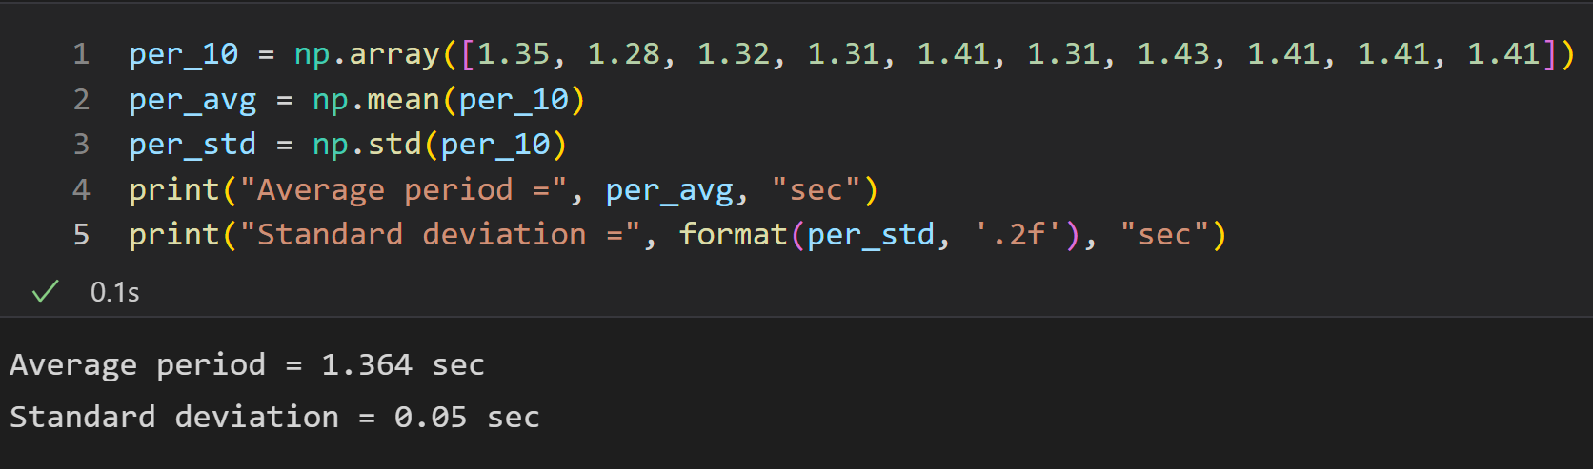

The standard deviation of the measurements was much less than the uncertainty estimated from a reaction time of 250 ms. This could be because the periodic motion of the pendulum made it easier to stop the stopwatch as the pendulum completed a cycle.

1. You can now do a quick calculation of *g*. Rearrange equation 8 and use your measurement of *T* and physical measurements to calculate it. Does it make sense?

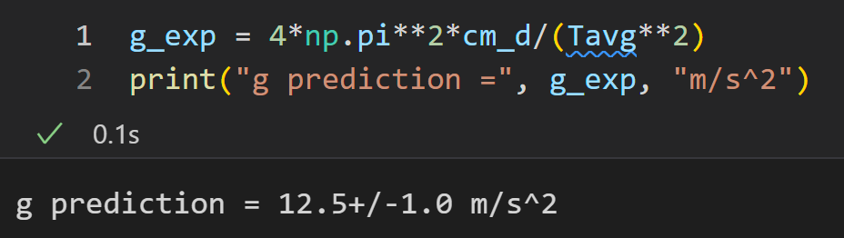

This predicted g is much higher than the accepted value. This makes sense because the approximation that the pendulum is point like is not accurate. The value is on the correct order of magnitude which indicates the data collected is not inaccurate.

1. Calculate the moment of inertia and distance from the axis to the centre of mass of the physical pendulum including uncertainties. Calculations which include uncertainty propagation can be tedious and are prone to mistakes. We recommend that you use the Uncertainties package to assist in this calculation. See below for instructions.

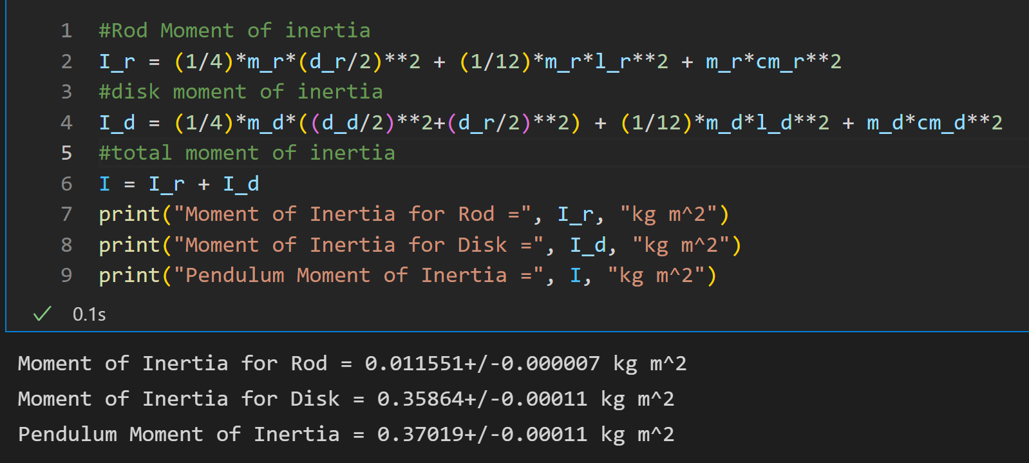

1. Spending no more than 15 minutes of lab time, measure the period as a function of angle by:

* Timing single oscillations of the pendulum; and then
* Timing multiple (10-30) oscillations of the pendulum.

Can you see when the small angle approximation no longer holds? Is this true for both measurements? What determines when this approximation holds?

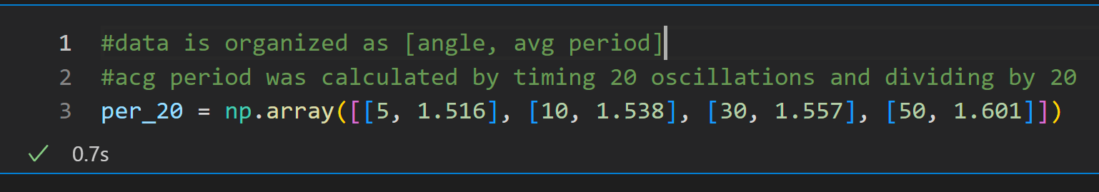

The approximation becomes inaccurate after the 10° trial. This is evident as the period is not the same to 2 significant figures after this measurement. The accuracy of this approximation is determined by the difference between sin(x) and x and 1 and cos(x). From the included plot below of sin(x) and x, the lines diverge substantially around 0.3 rad or ~17°. Single oscillation measurements were not completed because we ran out of time.

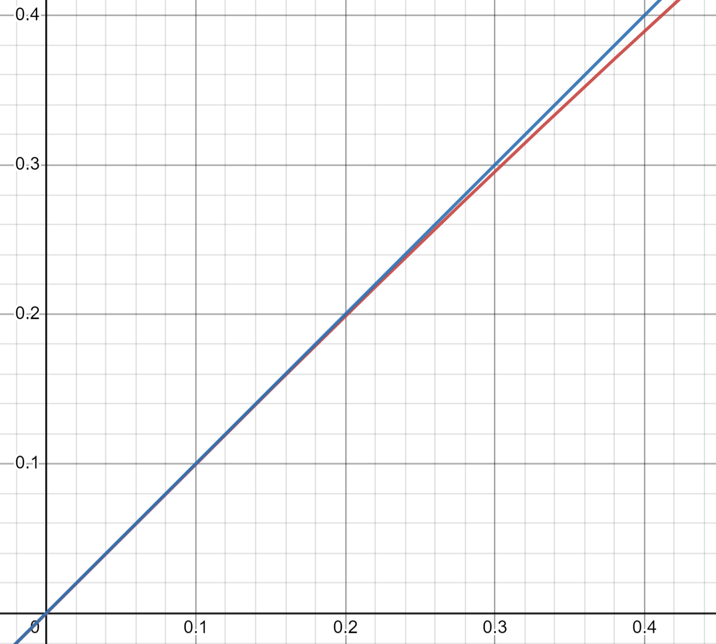

1. How small will the uncertainty have to be in order to see the difference in g due to

centripetal acceleration?

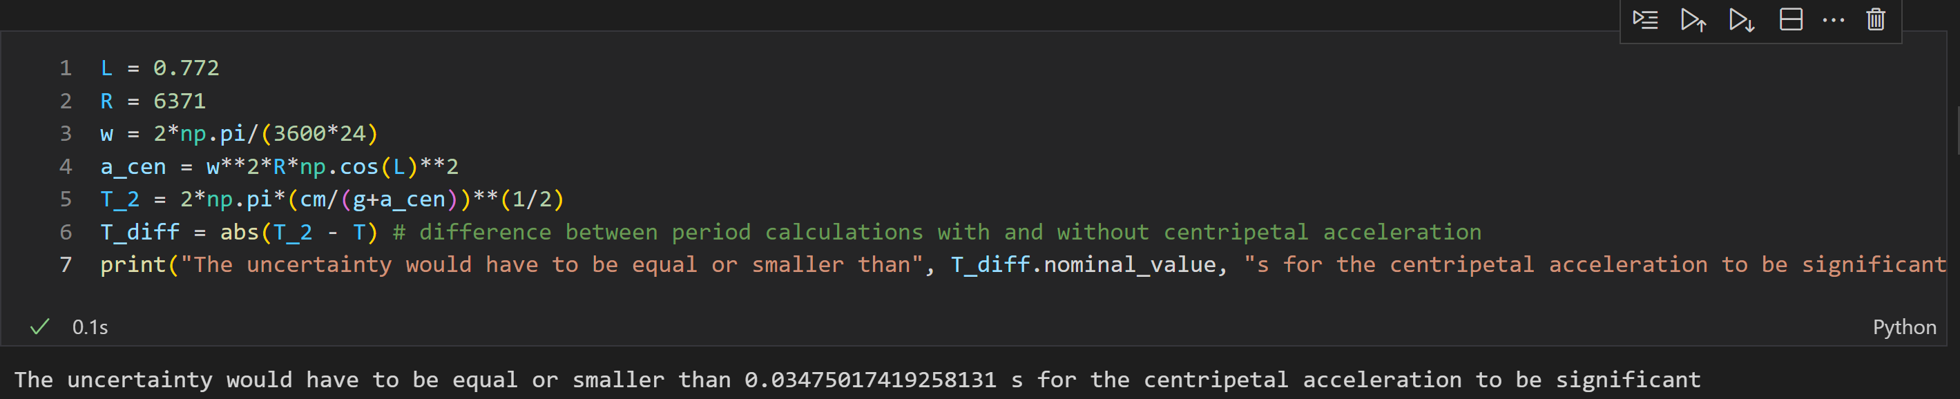

The uncertainty would have to be equal or smaller than 0.035 s for the centripetal acceleration to be significant.

1. Using the serial monitor and manual manipulation of the pendulum, determine the units

for the output. The encoder outputs an integer number of steps per revolution. What is the

conversion from encoder number to degrees?

The steps increment by about 500 for a rotation of 90°, thus the encoder is set to 2000 steps per revolution. This is 0.18°/step.

1. Take a series of data with increasingly long recording times. Be careful to see if there

is any spurious motion in the pendulum - any motion out of the plane is not considered in

our current models. Be sure to record file names, paste images of the graphs of the data, and

comment on the quality and reliability of each data set in your lab notebook. Do some quick

checks - are you getting the same data with the encoder measurements as you were with the

stopwatch?

**

The period of each data set is less than 1.5 seconds which lines up with previous measurements.

1. Fit your data using some of the models described earlier in the instructions. Estimate

the starting values for each parameter using your manual data. Paste your data+fits into your

lab notebook, and take special note of any major discrepancies.

1. What is the accepted value of g in Kingston according to this model?

1. Compare the fitted values for the data you took and various fit models. Are the fits  
   acceptable? Is there some refinement to the fit function that could be made?

For the fits above from left to right, top to bottom, the reduced chi squareds were 2.33, 1.39, 1.09, and 2.72. This implies that the fits are acceptable, and the fit function is good at modeling the data.

1. What is your best estimate of the value of g from this experiment, and what is your  
   uncertainty on this measurement?

From this experiment the best estimate of g was 9.7900 ± 0.0015 m/s2 and was the result of the fourth data set with an angular frequency of 4.099600+/-0.000029 rad/s.

1. Does your measurement agree with accepted values for g? If not, there is something  
   wrong with either your model, your uncertainties or there is a systematic problem that hasn’t been addressed. Why do you think your experiment doesn’t agree?

Our result does not agree with g within the calculated uncertainty. I think that the experiment doesn't agree because of an error in the model. The model does not account for the effect of air resistance or the friction in the rotary encoder on the angular frequency. These would resist the motion of the pendulum and thus would decrease the frequency. Since g is proportional to ω2 this would decrease the value of g. Though these factors are likely negligible, they could account for some of the 0.14% error on the result. The error in the value of g could also be the result of simplifications in the calculations of moment of inertia as the threads of both the rod and disk were neglected, the hole in the rod was not accounted for and the moment of inertia of the rotary encoder was not included. These would likely have a small impact on the total moment of inertia however the calculated value of g is proportional to the moment of inertia so the small decrease in moment of inertia could by why the calculated value of g does not agree with the accepted value.

1. What measurement contributes most to the uncertainty? Include your sensitivity analysis.

From the sensitivity analysis, the largest sources of uncertainty in the calculated g were the diameter of the rod, the distance from the top of the rod to the centre of the hole, and the length of the threads on the rod.

1. How could this experiment be improved to yield a better result?

To yield a better result, the experiment should be repeated with a smaller angle of oscillation. This would lower the maximum speeds of the pendulum, decreasing the air resistance and likely decreasing the side-to-side motion of the pendulum. A smaller angle of oscillation would also increase the accuracy of the small angle approximation, which could improve the accuracy of the results. However, if the angle of oscillation was low enough, the noise of the rotary encoder readings could become significant compared to the amplitude of the angle readings causing a reduction in accuracy. Finally, more measurements could be taken to more accurately calculate the moment of inertia which would have a very small effect, but could slightly improve the results.